**CHAPTER III**

**TECHNICAL BACKGROUND**

In this chapter we will discuss what are the technical background and the tools that are used in making this project.

**Architecture Design**

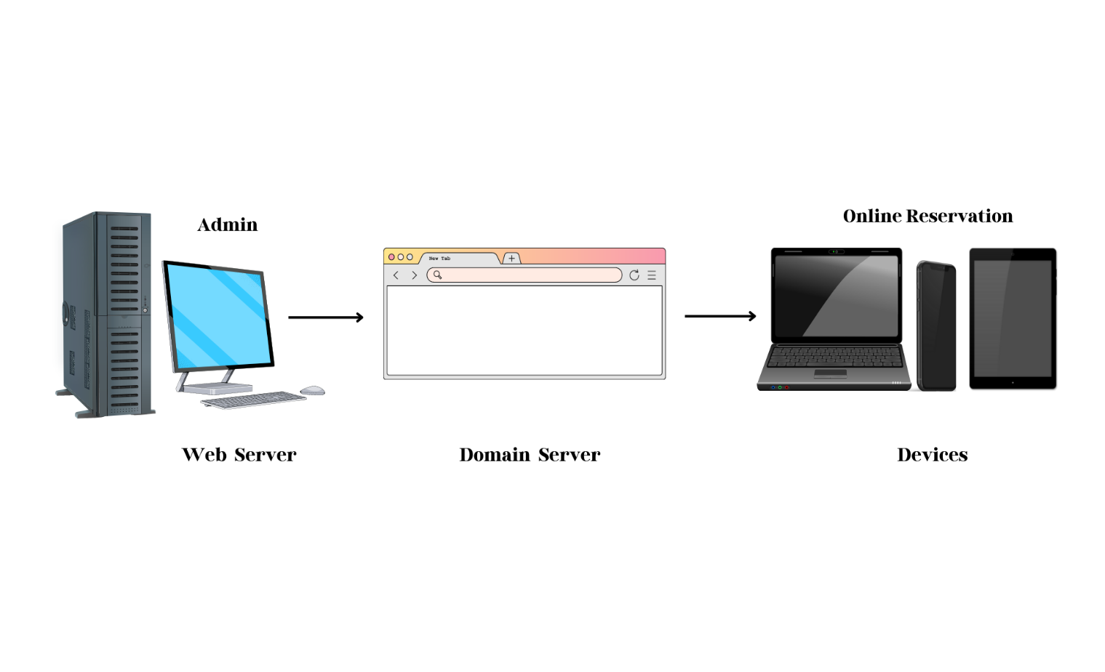

This system will use a web server, a domain server, and online reservations. This system encrypts all the data that the administrators need. All teacher reservations will be automatically calculated, sent to the admin/client, and displayed. If you need to cancel your reservations, you may do so. Our system may only be intended for teachers and admins. After all teacher reservations are made, the admin may examine and monitor the domain server for each sale and reservation.

The MDC Canteen Customer Management with recordings, reservations, and inventory web application runs on a web server. It has a domain server, making it possible for the administrator to access it from a location remote from the main web application and on any device. If they are making an online reservation, not only the administrator but also the teachers have access to the web application.

**3.1** **Details of Tools and Technology Used**

The technology that will be used in this system as follow:

**XAMPP 1.8** - Developers will use this as a development tool to allow website programmers to test their work on their own computers without any access to the Internet.

**MySQL** - pronounced either "My S-Q-L" or "My Sequel," is an open-source relational database management system. It is based on the structured query language (SQL), which is used for adding, removing, and modifying information in the database. Standard SQL commands, such as ADD, DROP, INSERT, and UPDATE, can be used with MySQL.

MySQL can be used for a variety of applications, but is most commonly found on Web servers. A website that uses MySQL may include Web pages that access information from a database. These pages are often referred to as "dynamic," meaning the content of each page is generated from a database as the page loads. Websites that use dynamic Web pages are often referred to as database-driven websites.

MySQL will be used by the researcher because it is one of the databases that is compatible with the development of the system.

**PHP: Hypertext Pre-processor (or simply PHP)** is a server-side scripting language designed for web development but can also be used as a general-purpose programming language. It was originally created by Rasmus Leadoff in 1994. The PHP reference implementation is now produced by The PHP Group. PHP originally stood for Personal Home Page, but it now stands for the recursive acronym PHP: Hypertext Preprocessor.

PHP code may be embedded into HTML code, or it can be used in combination with various web template systems, web content management systems, and web frameworks. PHP code is usually processed by a PHP interpreter implemented as a module in the web server or as a Common Gateway Interface (CGI) executable. The web server combines the results of the interpreted and executed PHP code, which may be any type of data, including images, with the generated web page. PHP code may also be executed with a command-line interface (CLI) and can be used to implement standalone graphical applications.

**Hypertext Mark-up Language (HTML)** It is the standard mark-up language for creating web pages and web applications. with Cascading Style Sheets (CSS) and JavaScript alongside.

**CSS stands for Cascading Style Sheets** - CSS describes how HTML elements are to be displayed on screen, paper, or in other media. CSS saves a lot of work. It can control the layout of multiple web pages all at once. External style sheets are stored in CSS files.

**JavaScript** - jQuery is a Java Script library that allows web developers to add extra functionality to their websites. It is open source and provided for free under the MIT license. In recent years, jQuery has become the most popular JavaScript library used in web development.

The tools or program we (will) used to code:

**Microsoft Visual Code** - It is a source code editor developed by Microsoft for Windows, Linux, and macOS. It is freeware to let computer programmers develop software and is provided by Microsoft. It allows programmers to develop applications and websites on platforms such as Visual Basic, Visual C#, Visual C++, JavaScript, PHP, etc. The Express Editions are more suitable for novice developers.

**Web Browsers -** A web browser (commonly referred to as a browser) is a software application for accessing information on the World Wide Web. Each individual web page, image, and video is identified by a distinct URL (Uniform Resource Locator or Web address like: https://www.wikipedia.org), enabling browsers to retrieve and display them on the user's device.

Here are some of the browsers:

1. Chrome Browser

2. Mozilla Firefox

3. Microsoft Edge

4. Opera Browser

There are a lot of other browsers, but those four are some of them and are very popular.

Here is the hardware that will be used are as follow:

For laptops and/or desktop:

* Minimum 5 GB HDD/SSD space
* At least Intel Pentium and/or AMD Athlon/Ryzen 3 processor
* At least 2 GB RAM

For tablets and mobile

* Android OS 4.2.0 and above
* IOS 9 and/or above